2022 Annual Child Rights Coalition Conference Report
21 and 22 November 2022
Rainbow Towers Hotel
Theme: “Our rights, our present and future”
Attendance.
Day | Male | Female | Total
1 | 45 | 59 | 104
2 | 45 | 54 | 99

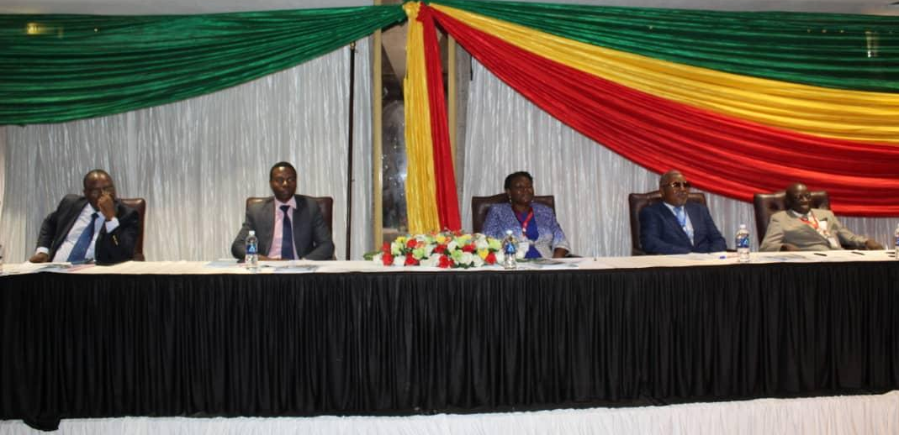
The Child rights Coalition conference head delegation from left to right- Member of the Parliament of Zimbabwe Hon.M. Nyashanu who is also the Chairperson of the Child Rights Parliament Caucus, Acting Deputy Director of Child Protection in the Ministry of Labour and Social Welfare Mr S. A Paungano, ZNCWC Board Chairperson, Mrs V. Nhemachena, ZNCWC National Director Rev T Nyanhete and ZNCWC Board Vice Chairperson Mr C. Pound.
INTRODUCTION
The Child Rights Coalition Conference 2022 was held in Harare at the Rainbow Towers Hotel from the 21st to 22nd of November 2022. It was held under the theme: “Our rights, our present and future”. The meeting was attended by several civil society organisations working on child-related issues, Senior members of the Parliamentarians, representatives of the Junior Assembly, Government Ministries, policy makers, children, private sector, media houses and other relevant stakeholders. Every year, the Child Rights Coalition conduct an annual conference to reflect on emerging issues on child rights; achievements, challenges and how the situation of child rights can be improved in the Zimbabwe and plan a road map for the fulfilment of child rights in Zimbabwe. The purpose of the conference was to bring together key actors in the Child Rights Sector to discuss the implementation of child rights in 2022 going forward and proffer recommendations for improvement for 2023.
2022 CONFERENCE OBJECTIVES.
- To share on the state of child rights in Zimbabwe, including current challenges faced in the COVID 19 pandemic (child protection, education and social service sectors)) and discuss on interventions,
- Deliberate of the possible intervention to ensure that children realise their rights present and, in the future, and
- To evaluate the achievements and challenges of the Child Rights Coalition for the year 2022, share good practices and plan for 2023 implementation.
ABOUT THE CHILD RIGHTS COALITION
The Child Rights Coalition (CRC) is a voluntary network of Zimbabwe Civil Society Organizations committed to ensuring that all children fully enjoy their rights as defined by the Convention on the Rights of the Child. The Child Rights Coalition provides a coordinated platform for CSOs action and plays a central role in key child rights developments at all levels in Zimbabwe. The Coalition's mission is to initiate and influence policies and actions to promote, protect and respect the rights of children in Zimbabwe. And to initiate a child rights mechanism for effective monitoring and reporting of child rights violations in Zimbabwe
WELCOME REMARKS AND PROGRAM OVERVIEW
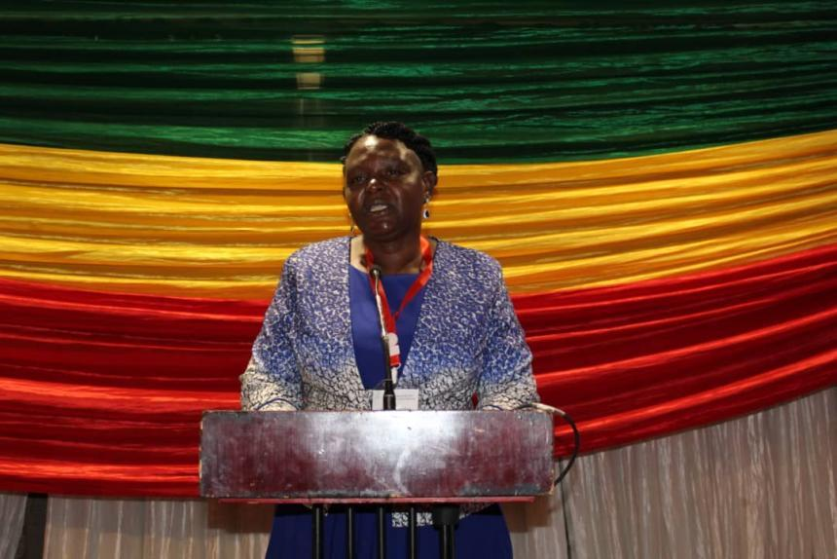
Welcome Remarks and Program Overview was given by the ZNCWC National Board Chairperson - Ms V Nhemachena. In her welcome remarks she shared the key notable progress that has been seen in the child rights sector on the policy changes in particular the new Marriages Act Number 1 of 2022, that has outlawed child marriages, and the Constitutional Court ruling raising the age of consent to sex to 18 years of age. Mrs Nhemachena showed great concern on the rising cases of sexual exploitation of young girls and encouraged the CRC members to act now and advocate for policy changes that enhance the protection of our children now and in the future.
The ZNCWC Board Chairperson, Mrs V Nhemachena giving welcome remarks

KEY NOTE ADDRESS FOR THE ACTING DEPUTY DIRECTOR OF CHILD PROTECTION IN THE MINISTRY OF PUBLIC SERVICE, LABOUR AND SOCIAL WELFARE FOR THE ZIMBABWE CHILD RIGHTS COALITION CONFERENCE 2022
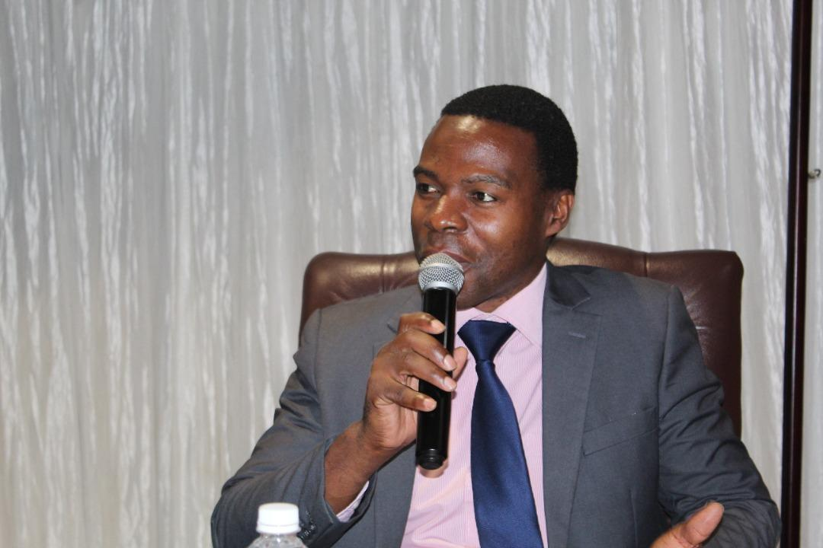
The Child Rights Conference is bringing together key stakeholders who play a critical role in the protection and promotion of children’s rights; that is, Government of Zimbabwe, civil society, development partners, policy makers, media and most importantly the children themselves. In this Conference, these stakeholders are coming together to assess Zimbabwe’s achievement of the Agenda 2040 and to proffer recommendations on the improvement of implementation of this framework. It is also an opportunity for child rights civil society to evaluate their achievements in complementing Government efforts in implementing child rights frameworks. Governments has put in place structures for every child to benefit fully from quality education and that all children are protected from violence, exploitation, neglect and abuse. States must ensure children who are in contact with the law are protected through a child-sensitive criminal system. State parties are required to protect all children from the impact of armed conflicts and other disasters or emergency.
situations.
In this regard, the Government of Zimbabwe has taken significant steps in achieving the aspirations of Agenda 2040. The state has facilitated the ratification and domestication of international child rights instruments. Progress has been noted on the existence of legal frameworks, policies and programs to support vulnerable groups, including children in difficult circumstances. In his speech, the Deputy Director applauded the role given by the Child rights coalition on working tirelessly in the implementation of these child rights laws, policies and programs as well as participating in the consultative processes for the Children’s Amendment Bill, Child Justice Bill, Guardianship of Minors Amendment Bill, Disabled Persons Bill, amongst others. Coalition members have mobilized children and young people to participate in local and national budget consultations in the interests of promoting child friendly budgeting.
In his remarks, he outlined challenges that are increasing children’s vulnerability in Zimbabwe. Some of the challenges that have negatively affected the situation of children are the COVID 19 pandemic, economic challenges and chronic food insecurity impacting their education, health, safety and protection. In the midst of the COVID 19 pandemic, Zimbabwe recorded a total of 10 297 children who dropped out of school and never returned when schools where reopened. Teen pregnancies, sexual exploitation and abuse, intimate partner violence, child marriage, are impediments to the rights of children – present and future. Recent reports have indicated disturbing accounts of child rights violations in the home, school, church and community, which is a cause of great concern to the child rights sector.
The speaker outlined that the Government of Zimbabwe actively seeks and fosters opportunities for partnership/stakeholder coordination with civil society, development partners, and private sector alike to strengthen efforts in protecting and promoting children’s rights.

CONFERENCE PROCEEDINGS
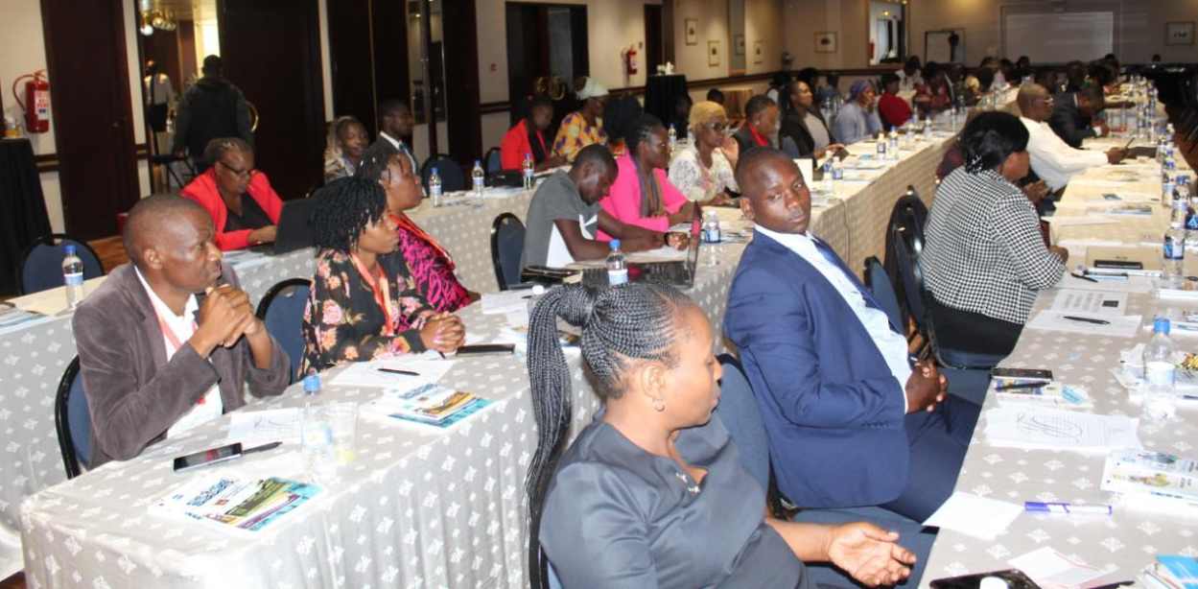
The Child rights Coalition Conference 2022 delegates
OVERVIEW OF THE CHILD RIGHTS SITUATION IN 2022- ZNCWC
A general Overview of children was shared focusing on key issues affecting children such as population, age, climate change, food security, poverty, health and nutrition. Key child related milestones were on the enactment of new policies, frameworks and programmes such as the New Marriages Act (Chapter 5.15) Number 1 of 2022 criminalizing child marriage. The Constitutional Court ruling on the age of consent to sex which was raised to 18 years of age, a measure to curb sexual abuse and exploitation. Expansion of COVID 19 vaccination programs in schools and measles vaccination exercise. National consultations on child rights laws thus the Child Justice Bill and the Children’s Amendment Bill amongst others. The Education amendment Act addresses issues pertinent to girls and education, including the prohibition of expelling pregnant girls from school, free and compulsory education and sexual and reproductive health issues. Cases of child abuse, violations and sexual exploitation have increased in the home, school and churches hence there is need to ensure safety for children in all places.
FEEDBACK FROM PARTICIPANTS
- inclusion of children with disabilities is cross cutting in all programmes,
- there is need for primary prevention and re-socialisation of the boy child to value and respect the girl child,
- CRC members should come up with comprehensive programme to curb drug and substance abuse, meanwhile the police should help eliminate drug sources and do away the ‘catch and release’ syndrome for drug sources, and
- there is need to ensure full implementation of the Education amendment Act and give teen mother s another chance in attaining education.

CHILD RIGHTS PARLIAMENTARY CAUCUS: ACHIEVEMENTS, CHALLENGES AND ACTION PLAN FOR 2023-By HON. DR M NYASHANU.
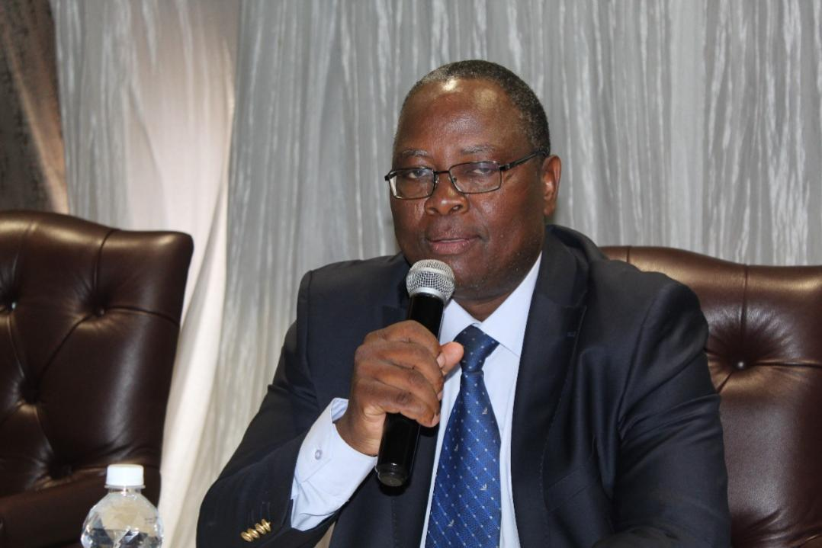
The Member of Parliament and the Parliamentary child rights caucus Chairperson Hon. Dr M Nyashanu.
The role of Parliament is to uphold the constitution and hold a democratic government. The Parliamentary Caucus on Child rights is a non-partisan, cross party grouping of Members of Parliament who work together to advocate for the full implementation of Zimbabwe’s constitutional provisions to promote, protect and fulfil children’s rights. The objective caucus is to advocate for the enactment and implementation of child sensitive laws, child friendly policies and child participation and engagement on issues that concern them in Parliamentary business. Key achievements were on the Official launch of the Parliamentary caucus on Child rights by the Deputy speaker of parliament Hon. Tsitsi Gezi on 16 of June 2022 and the recruitment of 45 members (25 females and 20males) to the caucus. The main challenge the caucus has faced is shortage of resources, they have never met physically as a team to discuss on children’s issues. The 2023 plans for the caucus are to;
- Review the work plan with all members of the caucus,
- Capacity building workshop/ dialogue meeting with traditional leaders on the plight of the girl child in Zimbabwe,
- Interactive meeting with vulnerable children in the grass roots,
- child-friendly budget analysis as soon as the budget is tabled in Parliament, and
- benchmark visit to Zambia/ Bangladesh.

UNPACKING OF NEW MARRIAGE ACT OF 2022 AND CONSTITUTIONAL COURT RULING ON THE AGE OF CONSENT TO SEX: - EFFECTIVENESS IN ENDING CHILD MARRIAGES AND SEXUAL EXPLOITATION BY WLSA
The presenter gave a background to the Court ruling of the age of consent to sex and detailed the new Marriage Act. On the 24th May the Constitutional Court declared that provisions of the Criminal Law Code governing the age at which children can consent to sexual intercourse were unconstitutional. The court was delivering its judgement in the case of Kawenda v Minister of Justice, Legal and Parliamentary Affairs & Others. The case was brought by Veritas and the appellant was represented by Mr Tendai Biti. The Criminal Law Code sections were unconstitutional because they do not protect children between the ages of 16 and 18. The High Court (Mr Justice Tagu) dismissed the application in January last year on the grounds that:
Teenagers naturally engage in sexual activity; the law cannot stop them from doing so and they should not be punished for it criminally, and many other statutes distinguish between children under the age of 16 and young persons between the ages of 16 and 18 all these statutes should be amended rather than just the sections of the Criminal Law Code. Hence, he declined to declare the sections to be unconstitutional. Understandably dissatisfied with this judgement [link], Ms Kawenda and her sponsors appealed to the Constitutional Court. As a result, the Court declared sections 70, 76, 83 and 86 of the Criminal Law Code to be unconstitutional and ordered them set aside. The Court however suspended its order to give the Government time to enact a law that protects all children from sexual exploitation. It did not however suspend its order in relation to the provisions in the sections that permit marital sex, i.e. sexual relations with children in child marriages. Those provisions, the court held, were unconscionable and had to be struck down immediately. the effect of the judgement is that if the husband of a girl under the age of 18 has sexual intercourse with her, he will commit the crime of having sexual intercourse with a young person in contravention of section 70 of the Criminal Law Code. That is the law now, so the Court has effectively abolished child marriages.
The new Marriage Act is in sync with the provisions of the Constitution, the new law seeks to introduce various new types of ‘marriages’ and modifies existing concepts within the marriages law framework. On the 27th of May 2022 the President of Zimbabwe passed into law a new marriages law, the Marriages Act (Chapter 5:15). This law has brought a radical change to the Marriage laws in Zimbabwe with the Marriage Act (Chapter 5:11) and Customary Marriages Act (Chapter 5:07) being repealed. The new Act introduces a civil partnership and a qualified civil marriage and recognises an unregistered customary law union as a marriage. All marriages are entered into between man and women above 18years of age. Facilitating marriage of children under 18years is now a criminal offence. The following marriage types outlined in the new Act;

1. Civil Marriage -Monogamous marriage (one man, one wife). Once married under this marriage, one cannot contract into any of the marriages discussed except the civil partnership. Otherwise, it constitutes bigamy which is a criminal offence. The marriage just requires two consenting adults over the age of 18. Lobola is not a requirement.
2. Registered Customary law union - Potentially polygamous marriage (one man potentially many wives). Requires payment of lobola and registration. Requires payment of lobola and can marry other women only under customary law, unless if there is still one wife, can upgrade to civil marriage. It is solemnised by Magistrates within their areas of jurisdiction.
3. Unregistered Customary law union (UCLU) - Polygamous marriage. This marriage is characterised by payment of lobola. A man can marry many wives under customary law. Should be registered within 3 months but there is no sanction for failure to do so. It is solemnised by a Chief within their area of jurisdiction. Can upgrade to registered customary law marriage.
4. Civil Partnership - Relationship between man and woman staying together without payment of lobola (cohabiting, situation-ships, small houses). Can stay with a married man or woman, also applies to boyfriends and girlfriends living together (kuchaya mapoto). This is not recognised as a marriage; it is only recognised for the purposes of determining rights upon death or dissolution of the relationship. Parties can upgrade to UCLU if payment of lobola is done.
5. Qualified Civil marriage - Civil marriage which is polygamous or potentially polygamous. Solemnised by the Minister of religion for Islamic rites.

FEEDBACK FROM THE PARTICIPANTS.
- The Marriages Act No.1 of 2022, effectively set the age of consent at 18, making it a punishable offence to impregnate or marry children below the stipulated age,
- The Marriages Act is commendable because it unequivocally abolishes and criminalises child marriages and will hopefully if implemented, protect children particularly girls, who over the years have borne the brunt of the unlawful and despicable practice, and
- More initiatives are required to sensitise communities on the provisions of the new marriage act.

UNPACKING THE CYBER AND DATA PROTECTION ACT [CHAPTER 12:07] (NO. 5 OF 2021) BY MINISTRY OF INFORMATION, PUBLICITY AND BROADCASTING SERVICES.
Zimbabwe is not left behind in embracing technological revolution that is occurring all over the world. The significant rise in access to the internet and other digital technologies means that children can engage, communicate, share, learn and develop while on-line. The proliferation of internet use has brought about numerous cyber security issues, especially when it comes to the protection of our youngest and most vulnerable digital citizens, which are our children who are below the age of 18 years. Today’s children are growing up in an environment in which information is accessible through a computer or a mobile device which has internet access. This has however given birth to the rise of cyber-crimes or cyber-security threats. Whilst the internet assists children in augmenting their learning experience, children need to be educated about some of the potential negative aspects borne of the techno-digital era.
Children need to be protected, stay safe and empowered both on and offline. They have rights, thus their privacy should be respected, protected and promoted. The best form of defence in protecting children is making them aware of what can happen on-line and make them understand that there is always a solution to a problem that they may encounter on-line. Empowering children and young people through education and raising awareness is therefore of paramount importance.
The provisions for the Data protection Act apply to matters relating to access to information, protection of privacy of information by the children looking at issues to do with: (a) child sexual abuse material as stated in section 165A Cyber and Data Protection Act and (b) exposing children to pornography as stated in section 165B of the Cyber and Data Protection Act. Child sexual abuse material means any illustration through publication, exhibition, cinematography, electronic means or any other means of any kind. It also means engaging in real or simulated explicit sexual activity with a child or any representation of the sexual parts of a child for mainly sexual purposes. Any person of 18 years or above, who unlawfully and intentionally through information and communication technologies, proposes to meet a child who has not reached the age of consent for the purpose of engaging in sexual activity with him or her, where this proposal has been followed by sharing of messages and inciting material leading to such a meeting, shall be guilty of an offence and liable to imprisonment for a period not exceeding ten years. The Act stipulates that any person who unlawfully and intentionally through a computer or information system makes pornographic material available to any child; or facilitates access by any child to pornography or displays pornographic material to any child; with or without the intention of lowering the child’s inhibitions in relation to sexual activity or inducing the child to have sexual relations with that person; shall be guilty of an offence and liable to imprisonment for a period not exceeding five years.
FEEDBACK FROM PARTICIPANTS.
- Participants were worried about the statement -’The cost of acquiring a device and costs of accessing the internet is within the reach of most of the citizens in Zimbabwe’. Generally, the concern was on the vulnerable and disadvantaged children who cannot afford to buy an electronic gadget and moreover access to internet,
- There is need to advocate for more resources to ensure rural schools are electrified and have access to internet,
- Parents should put control measures and control what children watch on their phones to reduce cyber-crimes, and
- There is need to offer PS to children who are victims of cyber-crimes and reduce the chances of suicide.
CASES TRENDS AFTER THE ENACTMENT OF THE CYBER AND DATA PROTECTION [CHAPTER 12:07] [NO.5 OF 2021] ACT AMONG CHILDREN BY ZRP-VFU
The Victim Friendly Unit was established in 1996 primarily to pro-actively and reactively police crimes of sexual nature committed against women and children in a manner sensitive to the victim. The Unit aims to be supportive of victims and to make the environment conducive, private and friendly. It further aims to be empathetic, meticulous, professional, expeditious, and maintain confidentiality when handling victims of sexual abuse. Protection of victims who have suffered or who are at the risk of suffering serious harm and ensuring that all reasonable efforts are made to safely maintain children in their own homes once abuse or neglect has been discovered or disclosed is one of its aims.
The Unit has also joined hands with other stakeholders in the multi-sectoral management of child abuse. Various methods of giving information on abuse whilst remaining anonymous like suggestion boxes and hot lines are also being marketed. In addition, victims are encouraged to report their cases direct to Victim Friendly Unit Coordinators who are found at each and every station. Since the establishment of the Unit, a remarkable increase has been realized in the reported number of cases of sexual abuse. This is attributable to the fact that members of the public have generally been conscientized and now discern what constitute an abuse and also another reason is that of the availability of good reporting system and the sensitivity of those receiving the reports.
PANEL DISCUSSION- MENTAL HEALTH ISSUES AFFECTING CHILDREN AND YOUNG PEOPLE: A FOCUS ON DRUG AND SUBSTANCE ABUSE
Panellists: Mubatirapamwe Trust, Zimbabwe Council of Churches, TAAF Zimbabwe.
The panel started defining mental health and its implications on children and the services organisations are offering to address the challenge of drug and substance abuse. ZCC outlined that mental health exist and gave models of defining mental health such as the traditional perspective which holds a believe that mental health is a result of a curse or witchcraft.
Hindering factors.
Due to the complex nature of psychological disorders, successful treatment often requires regular access to mental health care professionals and a variety of support services. Unfortunately, mental health care services are often not available or are under-utilized, particularly in developing countries. Common barriers to mental health care access include limited availability and affordability of mental health care services, insufficient mental health care policies, lack of education about mental illness, and stigma.
Effects of crystal meth.
Methamphetamine (d-methamphetamine, crystal meth, or meth) is a man-made central nervous system stimulant. Meth is a highly addictive substance, and its use is associated with a number of severe consequences. The mechanism of action of the drug is similar to other stimulants, in that its consumption results in massive releases of the neurotransmitters norepinephrine and dopamine (along with other neurotransmitters) that lead to a number of extremely powerful euphoric effects, increases in energy, feelings of invulnerability, and other psychoactive effects. The short-term and long-term effects of methamphetamine use indicates that there are a number of significant potential dangers associated with its use, including significant neurological effects and bi-polar.
causes of high incidences of drug and substance abuse.
People from all walks of life can experience problems with their drug use, regardless of age, race, background, or the reason they started using drugs in the first place. Some people experiment with recreational drugs out of curiosity, to have a good time, because friends are doing it, or to ease problems such as stress, anxiety, or depression. While your genes, mental health, family and social environment all play a role, risk factors that increase your vulnerability include: Family history of addiction, abuse, neglect, or other traumatic experiences, peer pressure, mental disorders such as depression and anxiety, bullying, idleness, trauma among other factors.
what the referral pathways for drug addicts.
The government of Zimbabwe has demonstrated modest support for mental health services through the development of the National Mental Health Strategy for Zimbabwe 2016 – 2020. Within the Ministry of Health and Child Care (MoHCC), the Department of Mental Health provides general oversight of mental health care in Zimbabwe. There are only two psychiatric hospitals, two psychiatric inpatient units, and seven outpatient mental health facilities functioning across Zimbabwe. Most of these facilities are in the public sector. Some facilities have been closed or are low-functioning due to inadequate resources for maintenance and repair. Both specialist mental hospitals noted a lack of trained and qualified staff to provide psychosocial interventions. Forensic facilities are responsible for a large proportion of mental health services in Zimbabwe; most patients at the forensic hospital sleep on the floor, and prison guards have been asked to care for patients. The primary care facility was implementing the Friendship Bench problem-solving therapy intervention with the support of lay counsellors.
FEEDBACK FROM PARTICIPANTS.
- There are no rehabilitation centres for drug and substance abusers instead survivors are placed in psychiatric units, and
- There is need to facilitate home care and community support to affected children and young people.
PANEL DISCUSSION- CHILD PROTECTION TRENDING ISSUES 2022- SAFETY OF CHILDREN IN HOMES, SCHOOLS, AND COMMUNITIES
Panellists - tdh, Justice for Children (JCT), Child Representative.
The panel discussed the role of their organisations on child protection, trending issues that are affecting children and the challenges they face on programming. These challenges include but are not limited to food insecurity, climate change, sexual exploitation, forced displacement/migration, mental health issues, drug and substance abuse among others
Role of Justice for Children - Justice for Children was the first Zimbabwean organisation to ensure that children’s legal issues are separated from those of women and the family. The organisation was also able to popularise child laws throughout the country resulting in increased sensitisation thereby leading to the realisation that this is an area of law with its own laws and policies that need to be implemented by different stakeholders in the justice sector. Further through popularisation of child laws, even players in the justice system began to see the need to develop a child friendly system with programs such as the Pre – Trial Diversion System, the Victim Friendly System and JCT has played a role in developing some of the policies that guide the funding of those programs. As a result of its work experience, the organisation further advocated for a section that speaks specifically to children’s rights in the Constitution of Zimbabwe. Through JCT’s intervention the 2013 Constitution is now more in line with both regional
and international laws especially in matters concerning children. The organisation remains very active in building the laws of child protection as it is currently participating in various engagements and consultations in the development of different laws which include the Child Justice Bill, the Marriages Bill, the Amendment of the Criminal Law Code (in particular around sexual offences), the Education Amendment Bill, the Persons with Disabilities Bill, and the Children’s Amendment Bill.

Role of ZNCWC - Zimbabwe National Council for the Welfare of Children (ZNCWC) is the umbrella body for the child rights sector that seeks to coordinate the child rights sector in Zimbabwe. Its major thrust is lobbying and advocacy, capacity building of membership, quality assurance on child -oriented initiatives, child participation and research. In this regard, ZNCWC coordinates organizations that are in the child rights sector. ZNCWC in its coordination role is the Secretariat of the Child Rights Coalition key roles of ZNCWC include advocacy, educating masses -awareness raising on child abuse, ensure inclusion of children.

Criminal capacity for juvenile offenders - Like any country in the World, Zimbabwe has developed laws that regulate human intimations to safeguard individual human rights and to protect society generally. There are two main legal instruments which deal with young offenders in Zimbabwe, namely the Children's Protection and Adoption Act (Chapter 33) (CPAA) and the Criminal Procedure and Evidence Act (Chapter 57). Consequently, there are two main institutions that deal with juvenile offenders, namely the juvenile courts and the magistrate's courts which administer the Children's Protection and Adoption Act and the Criminal Procedure and Evidence Act respectively. When a juvenile is alleged to have committed an offence the law requires that the matter be referred to a probation officer, who then prepares a social inquiry report highlighting the socio-economic circumstances of the juvenile. These special circumstances of the juvenile are supposed to be taken into consideration in the disposal process in an effort to achieve juvenile justice. The minimum age of criminal responsibility In Zimbabwe, under 7 years, a child is not subject to legal process. Between the ages of 7-18 years, a 'juvenile' is subject to legal process, but with the subdivision that from 7 to 14 years a child offender has situational factors taken into consideration, while the emphasis between 14 and 18 years is on punishment
Models of operation - TDH has several models namely; Youth networks to deal with young people, MAPS strategy, mainstream livelihood and food security, training ECD teachers, youth participation, youth engagement, advocacy in schools and engagement with policy makers and community dialogues
Challenges - Child headed households and child labour, resistance, stigma and discrimination

DAY 2 PROCEEDINGS
PREVENTION OF SEXUAL EXPLOITATION AND ABUSE REFRESHER TRAINING - FOST
This training focused on how organisations can keep children safe when they interact with our personnel, partners, programmes, and operations. This training introduced the principles of child safeguarding and the ways in which you can keep children safe. Prevention of SEA is a long-term goal. The training aimed to; (a) Describe what child safeguarding is and why it is important, (b) Identify child safeguarding responsibilities that apply to all personnel at all times. It is the responsibility of each organisational to put in place policies, organisation management, Human resources systems, offer mandatory training, put in place reporting structures and ensure there are assistance referrals, investigation guidelines and corrective Action - correct and respond when a report is made. Make sure the environment is safe for all staff.
FEEDBACK FROM PARTICIPANTS.
- CRC members should ensure that their organisations have child safeguarding and protection policies in place,
- There is need for staff to be continuously trained on child safeguarding and child protection,
- All reports on child safeguarding concerns must made in good faith, and
- key to safeguarding is prevention and making reporting concerns as early as possible for children, parents, communities and staff
PANEL DISCUSSION: PUBLIC INVESTMENT IN CHILD RIGHTS.
Panellists; Ashley Mundanda-Jnr MP Glen view constituency, Dr Michael Pasara - Economist and Hon. Dr M. Nyashanu- Member of Parliament.
Child friendly budgeting ensures that children get a fair share of resources. There are usual complaints or call from various Caucuses including this one on the need to disburse allocated funds quickly. Most allocated funds are disbursed towards the end of the year which is usually in September. Whilst the call is noble, it is also important to understand that Budgets are made on expected revenue and not available revenue thus it takes time for the government to actually raise these funds. Moreover, the complexity is now added by a shrinking base of the formal sector. In child friendly budgeting, there is also need to appreciate that there is direct and indirect budgeting. Most of the analysis are anchored on direct budgeting. However, emphasis should also be placed on indirect child friendly budgeting which includes but not limited to empowering of key institutions. such as law enforcement agencies, judiciary, parliament among others. From a public policy perspective, Zimbabwe has significantly developed policies to child protection, domesticated of International and regional policy. Child rights caucus in its collective desire wants to see an improvement on children’s lives. Some resources committed by the Government may not go directly to children but will be directed towards salaries. It is important to get resources to ensure and enforce the rights of children.
We need to be creative in our approach in financing child rights. Investments on children is still lagging behind. There are still gaps for resourcing for child protection, decline for infant education, a considerable amount of the budgets is going towards salaries at 70% on average, not the actual program implementation such as 30% of BEAM recipients. There is need to consider domestic mobilisation of resources. Domestic mobilisation is the process through which countries raise and spend their own funds to provide for their people is the long-term path to sustainable development finance.
Opportunities for children to engage with the caucus- that the purpose and intentions to interact with children, at every budget formulation process, children reps do participate and make presentations. Children are engaged at various levels of their constituencies. Efforts are on advocating for Children’s ministry.
OUR RIGHTS, OUR PRESENT, OUR FUTURE: -VOICES OF CHILDREN - HONORABLE VIMBAI GUKWA.
Child representatives were consulted on the National budgeting process showing that the Government of Zimbabwe is listening to the concerns and issues of children. As the leadership for children, they are concerned with the recent sexual exploitation and abuse cases especially the recent case of 9-year-old girls who were impregnated which is a clear depiction of the violations of children happening. They recommend stiffer penalties. People violate children’s rights because people do not know our rights. Rights are attached to responsibilities. Provide a listening ear to children.
Child participation - Zimbabwe is the leading country in the region that provides a listening ear to children. On an annual basis the President takes time to listen to junior parliamentarians to hear the issues of children. How you treat children determines their future that government and leaders of tomorrow. As a country, we need to adapt to technology and start action. As the CRC there is need to create equal opportunities, lets focus on equality and program for boys as well
BREAKAWAY SESSION (CHILDREN ENGAGE WITH THE CHILD RIGHTS PARLIAMENTARY CAUCUS) THE REALITY OF CHILDREN NOT TALKED ABOUT.
Below are the key issues outlined by child representatives during the interface meeting with the child rights parliamentary caucus;
FINANCING | CHILD PROTECTION
Funding of junior parliament to sit on a quarterly basis, – currently, sitting of junior parliament is ceremonial. | Improve support for survivors of abuse as communities and parents cover up for perpetrators
Budget monitoring and tracking is critical in understanding where expenditure on children rights is spent, understand leakages. | Address root causes of drug abuse which is rampant amongst children and young people
Caucus to develop a monitoring tool on fund allocated to children overall across the five ministries. | Strengthen reporting mechanisms and investigations as Childline is overwhelmed to handle the influx of calls being made. Minority languages in the call centre must be prioritized. Digital reporting mechanisms to be considered.
Incorporate the junior parliament into the children’s amendment so it accesses financing from treasury.
PARENTING | PARTNERSHIPS AND COLLABORATIONS
Parent child communication is limited in local communities as there are competing priorities. | Involvement of stakeholders, parliament and local leaders support in community intervention projects
Engagement of parents and awareness campaign and programming around these issues including sexual abuse and exploitation | Engage MP’s and community leaders to input into project proposal to ensure development initiatives are all inclusive
Capacitating parents and guardians on child rights and responsibilities | Institutional support to ZRP to ensure the safeguarding of rights of children.
SCHOOL PROGRAMMING
Capacitate schools with resource on first aid emergencies
Schools are not designed to be disability friendly and no specific teacher allocation to work with children with disabilities.
Guidance and counselling is not being prioritized at schools despite it being there.
Schools are ill equipped to respond to abuse issues and confidentiality of cases is not respected.

DOCUMENTATION AND JOURNALISM ON CHILDREN’S ISSUES - CITIZEN CHILD
Children’s issues were periphery but currently with the advent of social media. Social media has made it easy to access people and to the offices that we want. Social media is a tool for advancement of children’s rights and should be used for development. Development agencies have been utilizing social media for years, using blogs, Facebook, Twitter, and other platforms to publicize their vision, purpose, and activities; spread news; build support; attract volunteers and donors; and engage with interested segments of the population. For development practitioners, social media and development is now entering a new and exciting phase. As internet connectivity spreads, and cell phone usage spreads even further, there are millions of new potential content creators gaining access to social media each year. More social media content aimed at development purposes can, and should, be created by the targets of development themselves. The benefits of this shift towards local media creation are clear. Social media enhances the ability of poor populations to voice their own concerns and priorities, and publicize their own vision and purpose. Self-advocacy is a form of empowerment not always delivered through traditional development projects. Key areas highlighted are the ethics in journalism, fake media/news, digital footprint on social media and safety on social media.
FEEDBACK FROM PARTICIPANTS.
- There is need for capacity strengthening on use of social media for development to all stakeholders in the children sector,
- Donors to fund communications and media,
- Child protection issues should always be at the forefront of any decision to publicise the image of the child, and
- There is need to continuously engage media and update them on concerns of children for advocacy.
CHILD RIGHTS, ENVIRONMENT AND CLIMATE CHANGE - REGIONAL NETWORK OF CHILDREN AND YOUNG PEOPLE TRUST (RNCYPT)
All children have children’s rights. These are rules specially for children, that tell where children have a right to. These rules are there to ensure that every child grows up healthy and safe. Climate change and its consequences for the environment has a huge impact, especially for children. For example, children are more vulnerable to be victims of natural disasters. And this is not all: children are bearing the consequences of this phenomenon, and the most vulnerable are the ones suffering the most. These are children with disabilities, girls and children from minorities. This means that climate change is also the cause of the growing inequality between children. The most important thing to remember is this: Children are the future! This means that the damage that is being done to the environment today, children have to live with in the future. That is why it is important for children to be educated and aware about the environment, so that they can change their own behaviour. Moreover, they should be able to participate in the discussion on what has to be done to make a sustainable development possible.
FEEDBACK FROM PARTICIPANTS.
- Need to create a learning platform for CSOs on child rights, environment and climate change,
- Children are not sufficiently recognised as holders of environmental rights; hence more work is required to sensitise the children themselves
KEY PRIORITIES FOR 2023
CHILD PROTECTION | HEALTH
VFU operate 24/7 and 365 days. Decentralised system | Ensure provision of PSS to children in need
Teach good parenting skills | Facilitate access to GBV services within 72hrs
Awareness on child rights and responsibilities to parents | Ensure children have easy access to health facilities - Transport
Birth registration -training on things are no longer critical to get a birth certificate | Children’s cases to be treated as emergencies at health facilities
Safety of children during elections | Mental health act amendment (2006) to address post-covid issues
Child participation and use media for development | Medical bill to be made an Act
EDUCATION | DISABILITY
Safety on children attending extra lessons | Prioritise children with special needs
Ensure implementation of the 2nd chance programme | All children be afforded equal access to education, health care services, work and employment, and social protection. Address attitudinal and environmental barriers to participation
LEGAL | GENDER
Alignment of laws e.g amendment of the criminal codification and criminal act. | Education act that has given the girl child another chance-
Child justice bill to be passed to law | Programming for boys
Provision of evidence to be made flexible for sexually abused children in courts
Prioritise cases of children and reduce time with the perpetrator at courts

CONFERENCE EVALUATIONS.
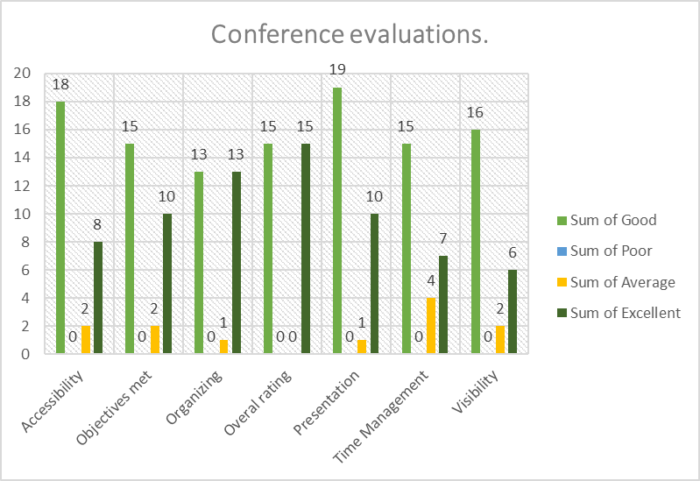

Data was collected using score cards. Participants marked sections as to their individual level of satisfaction. A total of 50 people completed the score cards. Diagram above shows different individual level of satisfaction, on a scale of good, poor, average and excellent. Overall, 50% of the respondents felt that the conference was good and 50% feel that the conference was excellent with poor recording zero responses.
COMMENTS FROM PARTICIPANTS.
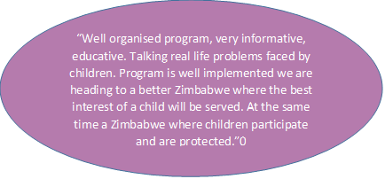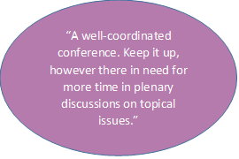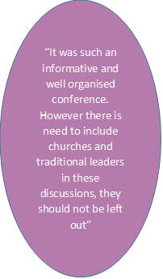

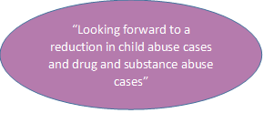
SUPPORTED BY:
